A project report on

**IMAGE ENHANCEMENT USING IMAGE PROCESSING**

Submitted in partial fulfillment of the Requirement for the award of degree of

**Bachelor of Technology**

In

**Computer Engineering**

Submitted by:

**Pawnesh Kumar Singh(2K14/CO/077)**

**Raja Kumar Ranjan(2K14/CO/092)**

**Rajit Meena(2K14/CO/094)**

**Siddharth Chaudhary(2K14/CO/121)**

Under the Guidance of:

**Mr. Anil Singh Parihar**

(Assistant Professor, Department of Computer Engineering , DTU )



2014-2018

Department of Computer Engineering

Delhi Technological University,Bawana Road,Delhi-110042

**CERTIFICATE**

This is to certify that Pawnesh Kumar Singh(2K14/CO/077), Raja Kumar Ranjan(2K14/CO/092),Rajit Meena(2K14/CO/094),Siddharth Chaudhary(2K14/CO/121) has carried out the minor project titled ***“Image Enhancement Using Image Processing”*** as a partial requirement for the award of Bachelor of Technology degree in Computer Engineering by Delhi Technological Technology.

The minor project is a bonafide piece of work carried out and completed under my supervision and guidance during the academic session 2014-2018.The matter contained in this report has not been submitted elsewhere for the award of any degree.

(Project Guide)

**Mr. Anil Singh Parihar**

Assistant Professor

Department of Computer Science Engineering

Delhi Technological University , Bawana Road

Delhi-110042

**ACKNOWLEDGEMENT**

We express our gratitude to our major project guide Mr. Anil Singh Parihar, Assistant Professor, Department of Computer Engineering, Delhi Technological University, for the valuable support and guidance he provided in making this minor project.

It is our pleasure to record our sincere thanks to our respected guide for his constructive criticism and insight without which the project would not have shaped as it has. We humbly extend our words of gratitude to other faculty members of this department for providing their valuable help and time whenever it was required.

Pawnesh Kumar Singh(2K14/CO/077)

Raja Kumar Ranjan(2K14/CO/092)

Rajit Meena(2K14/CO/094)

Siddharth Chaudhary(2K14/CO/121)

**ABSTRACT**

Nowadays image processing has become a prerequisite in most of the major applications such as surveillance, remote sensing, navigation, medical science, human identification, radiography, forensics etc.

Different image processing techniques deployed in different applications help to find particular features and analyze the image for specific purposes. There is a wide domain of such techniques used specifically.

One of the major areas of image processing is contrast enhancement in which intensities of image are distributed over the entire range of intensities in proportional to original image so as to achieve maximum contrast.

There are various methods proposed and analyzed in this field such as histogram equalization, BBHE, MMBEBHE, RSIHE etc. The proposed approach achieves contrast enhancement thereby restoring maximum brightness and content of an image. Results show a visually better image and are compared with other algorithms using image evaluation parameters.

**CERTIFICATE 2**

**ACKNOWLEDGEMENT 3**

**ABSTRACT 4**

**TABLE OF CONTENTS**

**List of figures 6**

**Introduction to Image Enhancement 7**

Algorithm for Histogram Equalization **10**

**Bi-histogram Equalization 11**

Algorithm for Bi-histogram Equalization  **13**

**Enhancement of Image using improve retinex method**

**Introduction**  **21**

**Retinex Algorithms 25**

Single Scale Retinex Algorithm(SSR) **27**

Multi Scale Retinex Algorithm(MSR) **28**

Multi Scale Retinex with Color Restoration(MSRCR) **28**

**CONCLUSION 33**

**REFERENCES 34**

**LIST OF FIGURES**

**Figure 1 Contrast Enhancement using Histogram Equalization 8**

**Figure 2 Result of proposed algorithm on Bi-Histogram Equalization 13**

**Figure 3 Result of proposed algorithm on Bi-Histogram Equalization 14**

**Figure 4 Result of proposed algorithm on Bi-Histogram Equalization 15**

**Figure 5 Result of proposed algorithm on Bi-Histogram Equalization 16**

**Figure 6 Result of proposed algorithm on Bi-Histogram Equalization 17**

**Figure 7 Result of proposed algorithm on Bi-Histogram Equalization 18**

**Figure 8 Result of proposed algorithm on Bi-Histogram Equalization 19**

**Figure 9 Result of proposed algorithm on Retinex Theory 30**

**Figure 10 Result of proposed algorithm on Retinex Theory 31**

**INTRODUCTION TO IMAGE ENHANCEMENT**

Image enhancement improves interpretability or perception of images for human vision and provides better input for automated image processing techniques.

The main objective of image enhancement is to change image attributes to make it suitable for a specific application or observer. The selection and modification of attributes varies with applications which introduces a great deal of subjectivity into the selection of image enhancement technique.

There are a lot of techniques which enhance images based on certain parameters producing specific changes. Edge detection and segmentation are the methods to detect edges, corners and objects in an image. Gamma correction changes the brightness of an image based on a fixed parameter gamma.

Contrast enhancement is one of the image processing areas which improves the visibility of an image by enhancing the difference in brightness of objects and their backgrounds. It is performed typically as a contrast stretch i.e. intensities are distributed over the entire range of intensities. Thus it improves the brightness differences across the dynamic range of the image.

It is better than tonal enhancements as tonal enhancements improve the brightness differences in different gray level regions (dark, mid, bright) at the expense of the brightness in the other regions.

A probability density function spanning full range of gray-level values produces a high contrast image; therefore, a low contrast image can be converted into a high-contrast image by stretching the intensity values so that the histogram spans the full gray values range.

The contrast stretch is referred to as histogram equalization. Histogram equalization is for contrast adjustment using histogram of the image. It maps the gray levels on the basis of the probability of distribution.

It flattens the histogram to occupy the entire range of gray levels values and thus results in contrast of the image. It increases the global contrast of images, specifically when the content of the image is presented by close values of contrast.

In this way intensities are better distributed on the dynamic range of histogram. This converts low contrast areas to high contrast. This process spreads out the high frequent intensity values efficiently to stretch the histogram. For a given image X, the probability density function p(Xk) is defined as

*p(Xk) = nk/n*(1)

for k = 0, 1, …, L – 1, where nk represents the number of times that the intensity level Xk appears in the input image X and L is the total number of intensity samples in the image. It is to be noted that p(Xk) is probability density function of the input image which represents the number of pixels that have a specific intensity Xk.

The plot of nk vs. Xk is known histogram of X. Based on the probability density function, the cumulative density function is defined as

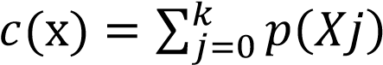 (2)

where Xk is the intensity level, for k = 0, 1, …, L – 1. Note that c(XL-1) = 1 by definition. HE is a method that maps the input image histogram so as to occupy the entire dynamic range, i.e. (X0, XL-1).

For this purpose, it uses cumulative density function as the transform function. Define a transform function f(x) based on the

##### CDF as f(x)=Xo + (XL-1 -Xo ) c(x) (3)

Then the output image of the Histogram Equalization, Y = {Y(u,v)}, can be expressed as

*Y=f(X)*

*={f(X(u,v)) |* ∀ 𝑋(𝑢, 𝑣)𝜖 𝑋*}* (4)

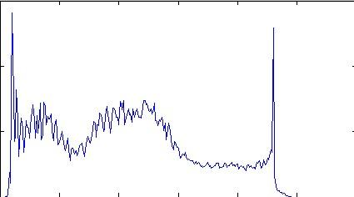 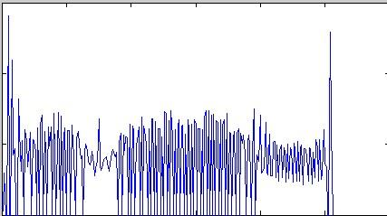

1. (b)

Fig.1. Contrast Enhancement using histogram equalization (a) Histogram of unprocessed image

(b)Histogram of histogram – equalized image

The performance of the HE to enhance the contrast of the image is the effect of expansion in the entire dynamic range. Besides, HE also flattens a histogram. As per information theory, the entropy of source will be the maximum when the message has the property of uniform distribution.

Furthermore, HE tends to combine gray levels of relatively low probability density, and results in decrease of entropy although such action tends to increase the contrast of an image.

**Algorithm for Histogram Equalization:**

1. Input the image, F (i, j) with a total number of ‘n’ pixels in the gray level range [X0 , Xn ].

2. Make the histogram of image.

3. The histogram stores the frequency of occurrence of each intensity value in the input image. For e.g. If pixel intensity of a particular element of the image matrix is ‘t’, then we write:

H(t)=H(t)+1; thereby storing the count of the corresponding pixel value .

4. Store the total no. of pixels in the image matrix in a variable.

5. For the particular image matrix calculate the probability density function(PDF) as follows:

For a pixel with intensity ‘t’:

PDF(t)=H(t)/(total no. of pixels)

6. After calculating the PDF for the given image, Determine the CDF (cumulative Density function) for the particular image as follows:

If pixel intensity is ‘t’:

CDF(t)=CDF(t-1)+PDF(t);

7. Multiply the contents stored in CDF array by 225 to normalize the intensity values onto a scale of 0-255.

8. Finally the new normalized matrix stores the enhanced image using HISTOGRAM EQULIZATION.

**Bi-histogram equalization (BBHE)**

This method was proposed to correct the problems of histogram equalization method. BBHE first separates the histogram of input image into two, dividing using its mean.

Thus, one has a range from minimum gray level to mean gray level and the other ranges from mean to the maximum gray level.

Next, it equalizes the two histograms independently. It has been analyzed both mathematically and experimentally that this technique is capable to preserve the original brightness to a certain extent, better than histogram equalization. Let Xm denotes the mean of the image X and Xm ∈ {X0, X1, …, XL-1}.

Based on the mean, the input image is divided into two sub-images XL and XU as

*X=XL U XU* (5)

where *XL ={X(u,v) | X(u,v) ≤ Xm* ∀*X(u,v)* ∈ *X}*

*XU ={X(u,v) | X(u,v)* ≥*Xm* ∀*X(u,v)* ∈ *X}*

Thus, the sub-image XL is composed of {X0, X1, …, Xm} and the other image XU is composed of {Xm+1, Xm+2, …,XL-1}.The respective probability density functions of the sub-images XL and XU as

*pL(Xk) = nkL / nL*

*pU(Xk) = nkU / nU*

where k = m+1, m+2, …, L-1, in which nkL and nk U represent the respective numbers of Xk in XL and XU, and nL and nU are the total number of samples in XL and XU, respectively.

Similarly, cL(x) and cU(x) are respective cumulative density functions for XL and XU. Note that cL (Xm) = 1 and cU (XL-1) = 1 by definition. Similar to the case of HE where a cumulative density function is used as a transform function, following transform functions are used to calculate equalized sub images:

*fL(x)= Xo+(Xm-Xo) cL(x)* (8)

*fU(x)= Xm+1+(XL+1-Xm+1) cU(x)*(9)

Based on these transform functions, sub images are equalized independently and the composition of the resulting equalized sub-images constitute the output of BBHE. That is, the output image of BBHE, Y, is finally expressed as

*Y ={Y(u,v)}* (10)

*= fL(xL)* ∪ *fU(xU) where fL(xL) ={ fL(x(u,v) |* ∀*X(u,v)* ∈ *XL}*

*fU(xU) ={ fU(x(u,v) |* ∀*X(u,v)* ∈ *XU}*

It should be noted that 0 ≤ cL(x), cU(x) ≤ 1, it is easy to see that fL(XL) equalizes the sub- image XL over the range (X0, Xm) whereas fU(XU)equalizes the sub-image XU over the range (Xm+1, XL-1).

As a consequence, the input image X is equalized over the entire dynamic range (X0, X L-1) with the constraint that the sample less than the input mean are mapped to (X0, X m) and the samples greater than the mean are mapped to (X m+1, X L-1).

The preservation of mean intensity of input image indicates the brightness preserving capability of an algorithm. The output mean of the BBHE is a function of the input mean brightness Xm.

This fact clearly indicates that the BBHE preserves the brightness compared to the case of typical HE where output mean is always the middle gray level.

**Algorithm for Bi-Histogram Equalization:**

1. Input the image, F (i, j) with a total number of ‘n’ pixels in the gray level range [X0 , Xn ].

2. Make the histogram of image.

3. The histogram stores the frequency of occurrence of each intensity value in the input image. For e.g. If pixel intensity of a particular element of the image matrix is ‘t’, then we write:

H(t)=H(t)+1; thereby storing the count of the corresponding pixel value

4. Segment F (i, j) into lower sub- images FL(i,j) and upper sub-image FU(i,j) based on its mean ‘XT ’.

Here mean can be assumed to be 127 as in case of images ,Intensity values of the pixel vary from 0 to 255(max. Value).

5. Equalize each partition independently using PDF and CDF.

6. For the lower sub-image FL(i , j) calculate PDF1 as follows:

PDF1(Xk)=H(Xk)/n , where n denotes the total no. of pixels in the lower sub-image.

Similarly, we can calculate the PDF2 for the upper sub-image.

7. CDF1 and CDF2 are obtained by taking the cumulative sum of the values in PDF1 and PDF2..

8. Finally multiply the values in CDF1 and CDF2 by 128 so as to normalize them to the normal image scale where 128 is the mean pixel intensity.

9. The final image is obtained by combining the INTENSITY VALUES obtained from the normalized array which stores the final intensity values.

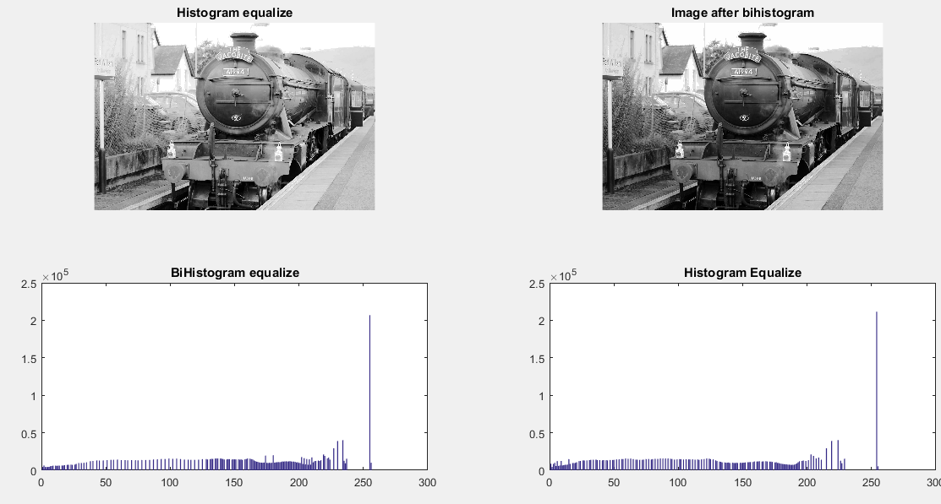

Figure 2

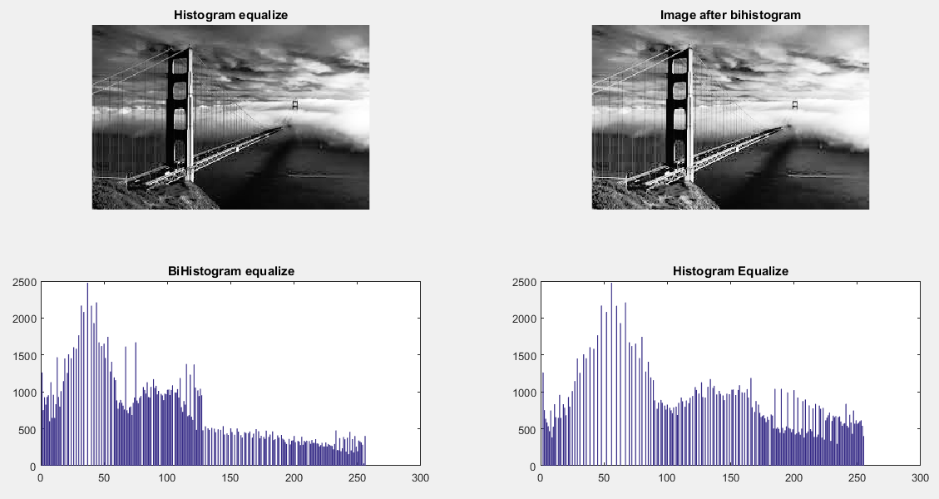

Figure 3

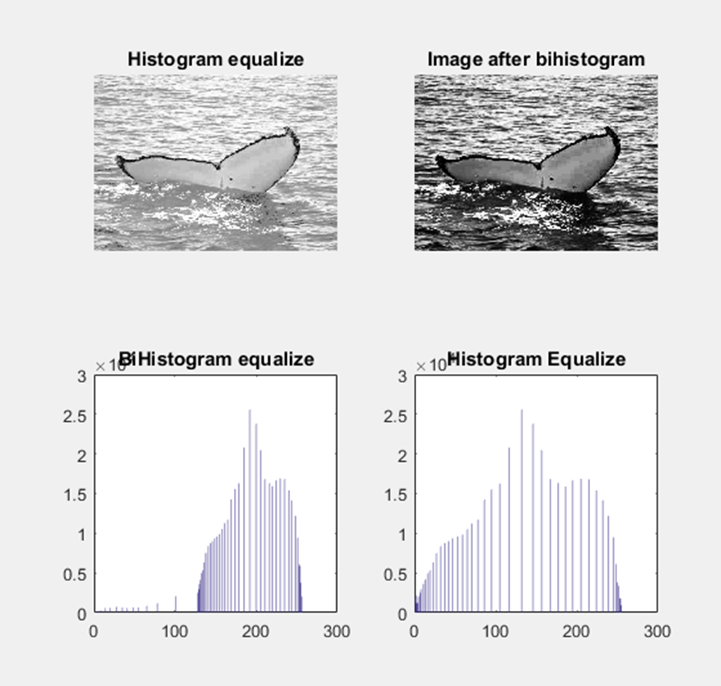

Figure 4

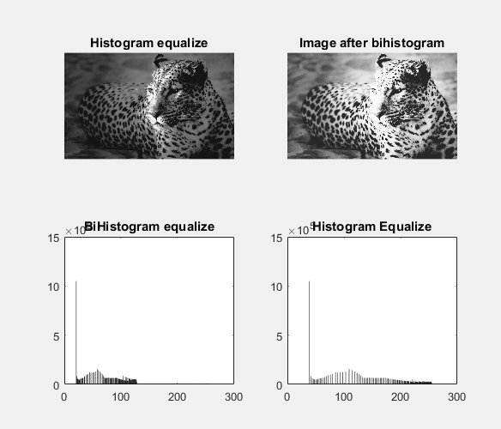

Figure 5

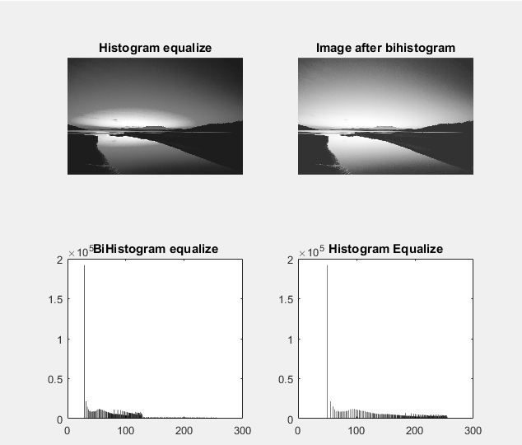

Figure 6

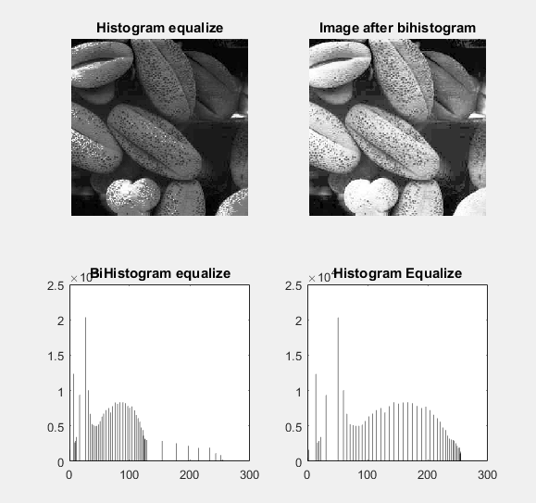

Figure 7

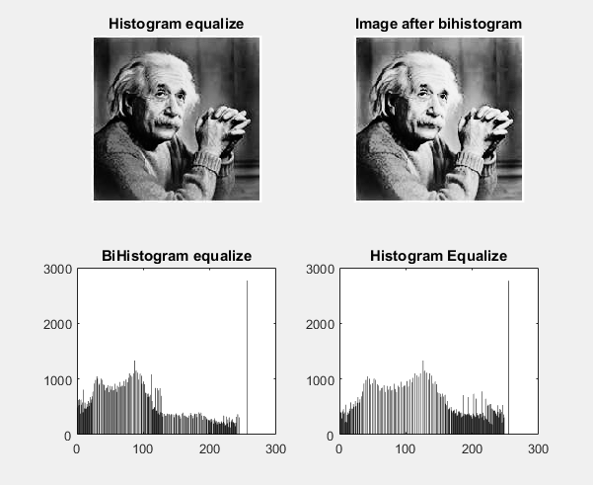

Figure 8

***ENHANCEMENT OF IMAGES USING IMPROVED RETINEX METHOD***

**INTRODUCTION**

Retinex Theory was formulated by Edwin H. Land In 1964. His theory and an extension, the “reset Retinex” were further formalized by Land and Mc Cann. It was the first attempt to simulate and explain the human visual system how to perceives color based on experiments using Mondrian patterns.

Several Retinex algorithms have been developed ever since and applied to many imaging field .Retinex algorithm is actually an image enhancement algorithm based on illumination compensation method. It explains the phenomena of colour constancy and contrast in which it is consider that perceived colors of objects are largely independent of the chromaticity of the light incident upon them.

These color constancy algorithms modify the RGB values at each pixel to give an estimate of the color sensation without a basic priori information on the illumination which is low-frequency component. Hence Retinex improves visual rendering of an image when lighting conditions are not good.

While our eye can see colors correctly when light is low, cameras and video cams can't manage this well. The retinex is aimed at obtaining the balance between the human vision and machine vision system along with color constancy.

Retinex model is based on the assumption that the HVS operates with three retinal-cortical systems, each processing independently the low, middle and high frequencies of the visible electromagnetic spectrum.

Besides digital photography, this algorithm is used to make the information in astronomical photos visible and detect, in medicine, poorly visible structures in X-rays or scanners.

In brief it helps to achieve many features such as sharpening, color constancy processing and dynamic range compression.

The Retinex Image Enhancement Algorithm is an automatic image enhancement method that enhances a digital image in terms of dynamic range compression, color independence from the spectral distribution of the scene illuminant, and color/ lightness rendition.

The digital image enhanced by the Retinex Image Enhancement Algorithm is much closer to the scene perceived by the human visual system, under all kinds and levels of lighting variations, than the digital image enhanced by any other method.

Image enhancement technology has permeated in many areas of science, engineering and civilian, such as biomedicine images, astrophotography, satellite pictures, computer vision, surveillance systems, civilian cameras, etc.

Color constancy failures and simultaneous contrast are two major phenomena which severely degrade the usefulness of colored (RGB) image. The color images have two major drawbacks due to scene lighting conditions.

First is the dynamic range problem which occurs when images captured and displayed by photographic and electronic cameras lose details and colors in shadowed zones.

The other is color constancy problem occurring due to loss of color distortions when spectral distribution of illuminant varies. So various algorithms based on histogram equalization algorithms based on retinex method,some on haze removal method and gamma correction etc are applied. Retinex theory considers how brightness and reflectance behave and investigates a computational model of color constancy human perception of color is largely independent of illumination conditions.

It shows that a captured 2D image can be decomposing into two sub images-one depends on their reflectance properties of the surface of the imaged object while other depends on the illumination conditions. So among these algorithms, retinex based algorithms have received more and more attentions.

The retinex theory is first proposed by Land to model the imaging process of the human visual system. This theory assumes that the scene in human’s eyes is the product of reflectance and illumination.

Most retinex based enhancement algorithms use different ways to estimate the illumination and remove it to obtain the reflectance as the enhanced image. The details and textures can be enhanced by illumination removal. While the enhanced results look over-enhanced and unnatural since the result does not meet with human vision system.

It is well-known that human eye perception is a combined effect of reflectance and illumination. It is unreasonable to remove the illumination and only regard the reflectance as an improved result.

Other retinex based algorithms firstly use logarithmic transformation to transform product into sum to reduce the computational cost, and then employ a variational model for enhancement. Note that the logarithmic transformation stretches low values and compresses high values, increasing the contrast of low intensities and decreasing the contrast of high intensities.

The resulting reflectance is usually smoothed and loses some details which can be manageable. In many papers, some novel retinex based image enhancement approach using illumination adjustment is proposed in which some new variational model is established that is different from conventional models, where the model does not need the logarithmic transformation and is more appropriate for the decomposition because reflectance is constrained in image domain.

So a fast alternating direction optimization method was adopted to solve the proposed old model, where the reflectance and illumination can be computed and decomposed. Then a simple and effective post-processing method of the decomposed illumination is used to make an adjustment for image enhancement.

The enhanced image is obtained by combining the reflectance and the adjusted illumination. The naturalness of enhanced images can be preserved while details enhanced.

Meanwhile, reflectance and illumination can be obtained as a byproduct of the enhanced Image and this method has good clarity on naturalness preservation and detail enhancement due to the illumination adjustment and precise computed reflectance.

Hence their common principle is to assign a new value to each pixel in an image based on spatial comparisons of light intensities. So with increase in better performance of retinex algorithm it is developed into many forms according to its application in grey images, color images and mostly in real time image processing in field of medical images and texture feature parameters.

**RETINEX ALGORITHMS**

The Retinex image enhancement algorithm is an image enhancement method that enhances an image with dynamic range compression. It also provides color constancy. It gives a computational human vision model. It deals separates two parameters.

At first the illumination information is estimated and then the reflectance is obtained from using division. It is based on the image formation model which is given by I (x, y) = L(x, y) r(x, y)

Where I is the input image, L is illumination and r is reflectance.

The image is first converted into the logarithmic domain in which multiplications and divisions are converted to additions and subtractions that makes the calculation simple. The sensitivity of human vision reaches a logarithmic curve.

The flowchart of Retinex algorithm is

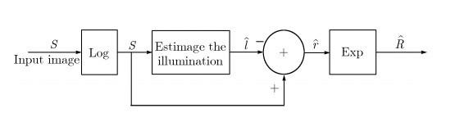

Here S is the input image. The illumination is estimated.

General Flowchart of Retinex Algorithm [1] Retinex is based on the center/surround algorithm. The given centre pixel value is compared with the surrounding average pixel values to get the new pixel value.

The input value of the center surround functions is obtained by its centre input value and its neighborhood. An array of photoreceptor responses is there for each image location. This is given as input to the retinex algorithm which has the receptor class for each location in the image.

The algorithm calculates a series of paths. For a single receptor class, it estimates the lightness values as a spatial array.

For computing each path, a starting pixel (x1) is first selected.Then a neighboring pixel (x2) is randomly selected. The difference of the logarithms of the sensor responses at the two positions is then calculated.

The position of pixel x2 is obtained by adding the previous step with the accumulator register which is given by: A(x2) =A(x2) +log(x2) −log(x1) (2) Where A(x2) is the accumulator registers for pixel (x2).

Counter register N(x2) for position x2 is incremented. All registers and counters are set to zero when the calculation starts.

The accumulation of position (xi) on the path is calculated by : A (xi) =A (xi) + log(x1). Then the counter register N (xi) is incremented. The first element of the path thus plays an important role in the accumulation for the path calculation.

The mathematical form of a Retinex is given by: Ri (x, y) = logIi (x, y) − log [F (x, y) ∗ Ii (x, y)], Where I is the input image, R is the Retinex output image and F is the Gaussian filter (surround or kernel) which is given by: F(x, y) =Kexp [−(x 2 +y 2 )/σ 2 ] (5) Where K is a normalization factor

The Retinex enhancement algorithms can be applied on all pictures. It provides better dynamic range compression and color rendition. It is an automatic process independent of inputs. These are the advantages of retinex algorithms.

The different types of retinex algorithms are:

(i)Single Scale Retinex algorithm (SSR)

(ii) Multiscale Retinex algorithm (MSR)

(iii)Multiscale retinex with Color Restoration algorithm (MSRCR).

**Single Scale Retinex Algorithm (SSR)**

Single Scale Retinex, is the most basic method for Retinex algorithm. A low pass filter is applied on Ii (x, y) which is the input color image to estimate the illumination. This illuminations log signal is subtracted to get the output color image Ri(x,y). It is a 2D convolution of Gaussian surround function and ith component of the original image.

It is given by Ri (x, y) = logIi (x, y) − log [F (x, y) ∗ Ii (x, y)] (6) Where i=1...S. Here, F (x, y) = K exp [−(x 2 + y 2 )/c2 ] is Surround Function, S is the number of spectral bands, c is surround constant or scale value and selection of K is such that ∫∫F(x,y) dx dy =1.

The log function in SSR is placed after the Gaussian surround function. A canonical gain offset is used as a post retinex signal processing. A space constant of 80 pixel is a good compromise between dynamic range compression and tonal rendition.

A single scale cannot simultaneously provide dynamic range compression and tonal rendition. The images are either locally or globally grayed out or suffered from color distortion due to violations of the gray world assumptions. These are the drawbacks of SSR.

**Multi Scale Retinex Algorithm (MSR)**

Single-scale Retinex cannot provide both the dynamic range compression and tonal rendition. Multi Scale Retinex (MSR) is developed to combine the strength of different surround spaces. The Gaussian filters of different sizes are used to process input image several times. The resulting images are weighted and summed to get output of MSR.

It is given by [18] Ri(x, y) = WnlogIi(x, y) - log [Fn(x, y) * Ii(x, y)] Where i=1, .S. Here, Wn represents the weight for the net scale, N is number of scales. MSR provide color enhancement. It also provides dynamic range compression and tonal rendition. The halos are reduced by using MSR. But MSR output images violate gray world assumptions. So it suffers from greying out of the image, either globally or locally. This gives a washed out appearance. This is the main drawback of MSR algorithm.

**Multi Scale Retinex with Color Restoration Algorithm (MSRCR)**

To restore color, MSR is modified by adding a color restoration function. The color restoration factor is given by: αi (x, y) = f[Ii (x, y)/ N∑n=1In(x, y)].

It is the color restoration coefficient in the ith spectral band. The number of spectral bands is given by K.MSRCR algorithm is given by, Ri (x, y) = αi (x, y) K∑k=1Wk logIi (x, y) − log [Fk (x, y) ∗ Ii (x, y)].

The block diagram of MSRCR algorithm is

MSR algorithm fails to meet Grey World Assumption. This problem can be removed by using color restoration method. Thus a color restoration factor (CRF) block is added with the MSR block to obtain the MSRCR algorithm

Main problems of MSRCR algorithm are the presence of halo artifacts at edges, graying out of low contrast areas and bad color rendition.

The MSRCR has halo artifacts in high contrast edges. The greying out effect of MSRCR is reduced by using adaptive filtering on luminance channel. At high contrast edges, these adaptive filter adapt the shape of the filter. In this way they reduces the greying out and halo artifacts.

But even then halo artifacts remains in images enhanced by using adaptive image enhancement methods. Halo artifacts in color images using, a fast edge preserving filter.But it reduces the contrast. The Gaussian surround function is modified in to reduce halo artifacts. But still it results in desaturation of color.

**PROPOSED SYSTEM**

The proposed system is a modification of multiscale scale retinex with color restoration algorithm.

It reduces the halo artifacts and graying out of images of multiscale retinex with color restoration algorithm and increases clarity of images. The improved MSRCR method uses multiscale retinex with color restoration algorithm and contrast limited adaptive histogram equalization.

The Contrast limited adaptive histogram equalization and the multiscale retinex with color restoration methods are applied to the low contrast image separately. The image fusion is used to combine their outputs. The output image obtained has more clarity than the output of existing multiscale retinex with color restoration algorithm.

Block Diagram for improved MSRCR Algorithm

A low contrast image is given as input image. The MSRCR algorithm is applied on this low contrast image. But the output image has graying out and halo artifacts at the edges.

CLAHE is Contrast Limited Adaptive Histogram Equalization. It operates on small regions of the image.These small regions are called tiles. The bilinear interpolation is used to combine these small regions of the image. By limiting the contrast in homogeneous areas, it reduced the noise in the images.

It enhances the contrast of these small regions of the image. The edge based color constancy can be attained by using CLAHE. It improves the local contrast of images. So graying out of the images and halo artifacts at the edges can be reduced using CLAHE.

CLAHE cannot be applied directly to the color channels in a color image as it changes the color balance of the image. So the image is first converted to the LAB color space. Then the algorithm is applied. After that the output image is converted back to the RGB color space.

The image fusion is used to combine the information in the two images into a single image which has more information than any of the two input images. Here image fusion block combines the output image of MSRCR and output image of CLAHE to produce single enhanced output image.

It merges the two images by wavelet decompositions.So the output image compare to the old MSRCR output image thus improving the clarity of the MSRCR output image.

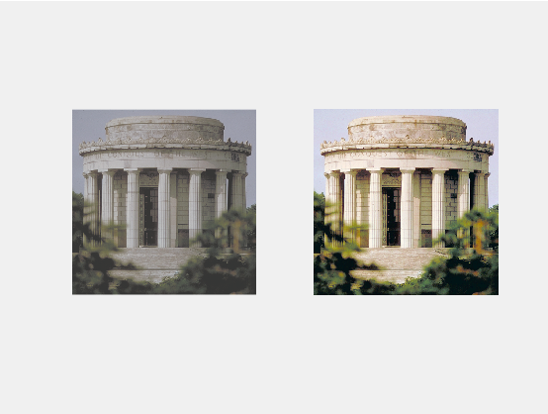

Figure 9

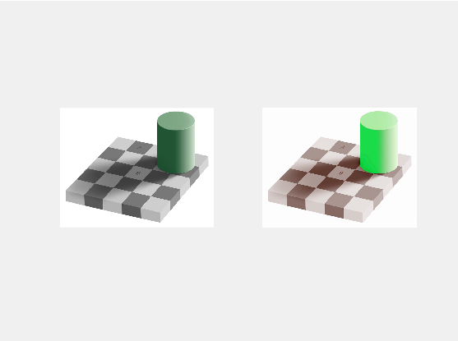

Figure 10

**CONCLUSION:**

In the presented work ,the technique of retinex for contrast enhancement of an image has been illustrated.

Histogram equalization method enhances the image’s contrast by normalizing the intensity distribution within the image in such a way that areas with very high intensity and very low intensity are equalized in terms of intensity distribution.

However , Histogram equalization technique does not preserve the mean brightness of the image .

So BBHE technique has been used which preserves the mean brightness of the image along with the contrast enhancement of the image.

However above two techniques don’t work on the coloured images because of the dynamic range of colours.

So the Retinex technique is used where the aim is to transform the visual characteristics of the digital image so that the rendition of the transformed image approaches that of the direct observation of scenes. Retinex is just the computerized form of the human eye visual system.

Here emphasis is placed on increasing the local contrast in the dark zones of images of wide dynamic range scenes.

**REFERENCES:**

[1] Yong-Tae Kim, “Contrast Enhancement Using Brightness Preserving Bi- Histogram Equalization,” IEEE Trans Consumer Electronics, vol. 43, no. 1, pp. 1-8, Feb. 1997.

[2] E. H. Land and J. McCann, “Lightness and retinex theory,” J. Opt. Soc. Amer., vol. 61, no. 1, pp. 1–11, Jan 1971.

[3] E. H. Land, “The Retinex theory of colour vision,” Scientific American, vol. 237, no. 6, pp. 108–128, Dec 1977.

[4] Zia-ur Rahman , Daniel J. Jobson, and Glenn Woodell. “ Retinex processing for automatic image enhancement.” Journal of Electronic Imaging 13(1): 100-110 (January 2004).

[5] L. Lei, Y. Zhou, and J. Li, “An investigation of retinex algorithms for image enhancement,” Journal of Electronics (China), vol. 24, no. 5, pp. 696–700, 2007.

[6] Z. ur Rahman and G. A. Woodell, “A multiscale retinex for bridging the gap between color images and the human observation of scenes,” IEEE Transactions on Image Processing, vol. 6, pp. 965– 976, 1997.

[7] D. Jobson and G. Rahman, Woodell, “Properties and performance of a center / surround retinex,” IEEE Transactions on Image Processing, vol. 6, no. 3, pp. 451–462, Mar 1997.

[8]. R. C. Gonzalez, R. E. Woods, Digital image processing (second edition), Publishing House of Electronics Industry, Beijing, China, 2007.

[9]. Ana Bel´en Petro, Catalina Sbert, Jean-Michel Morel

,Multiscale Retinex.